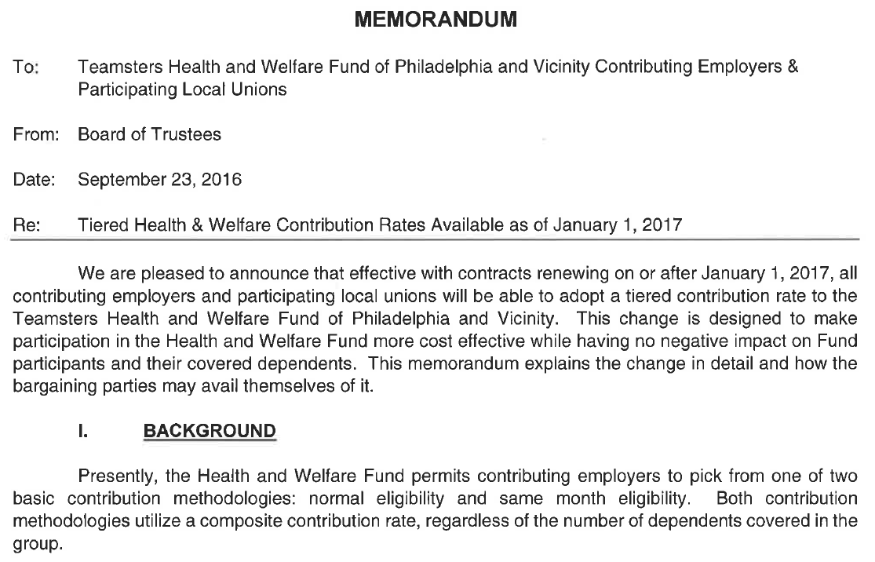
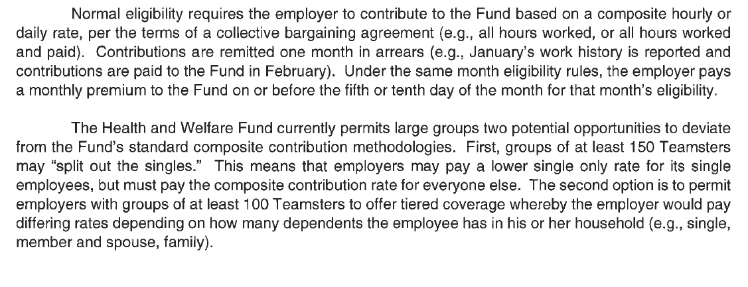

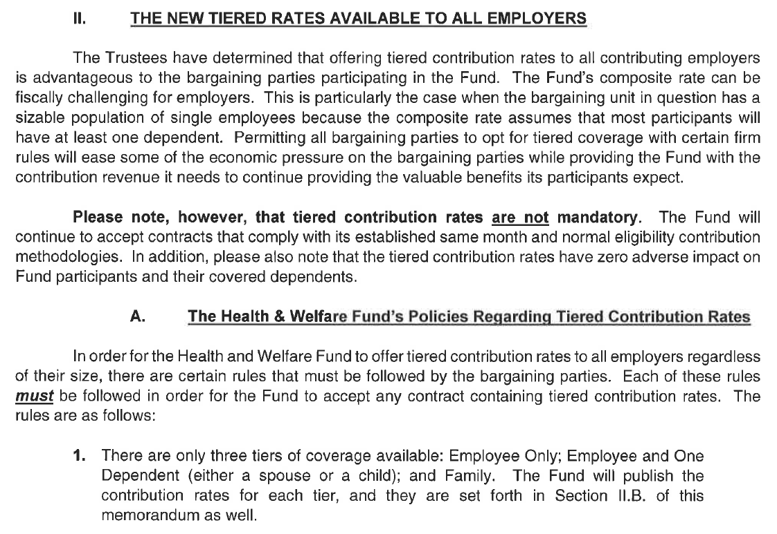
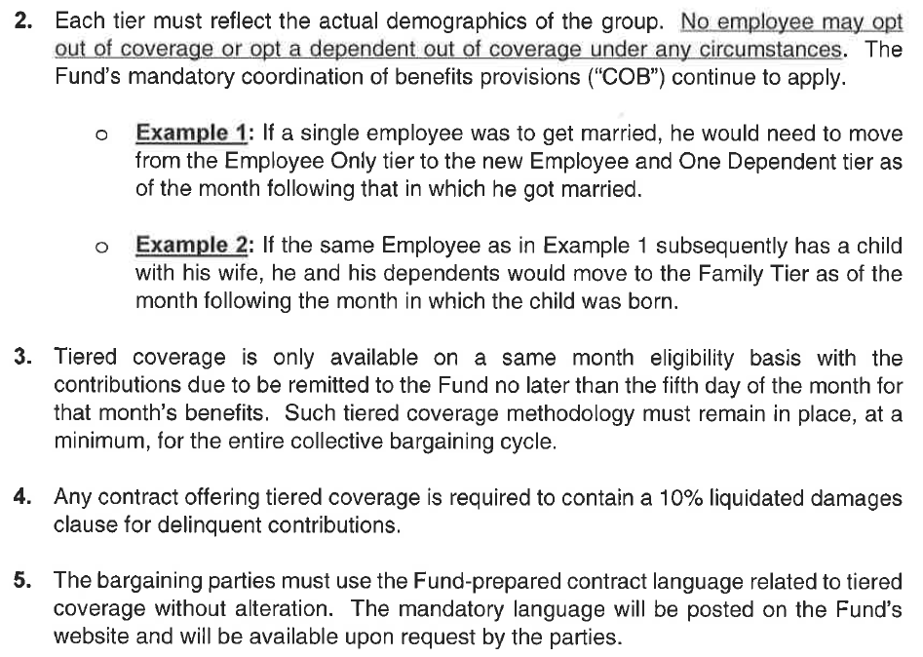

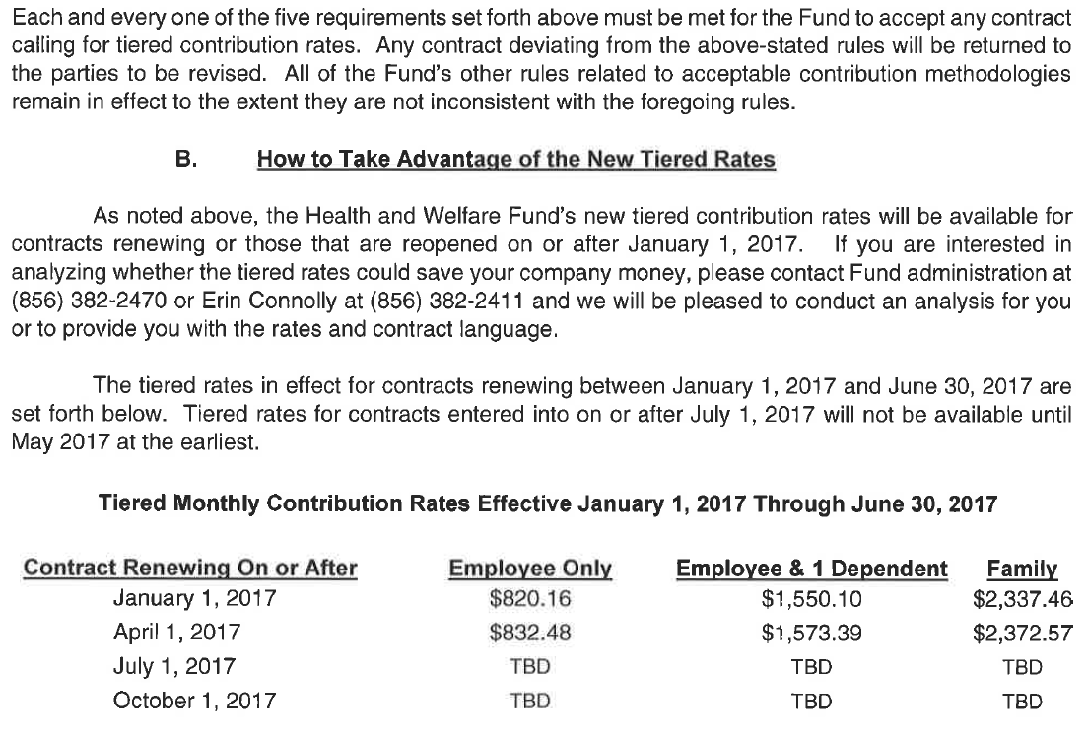
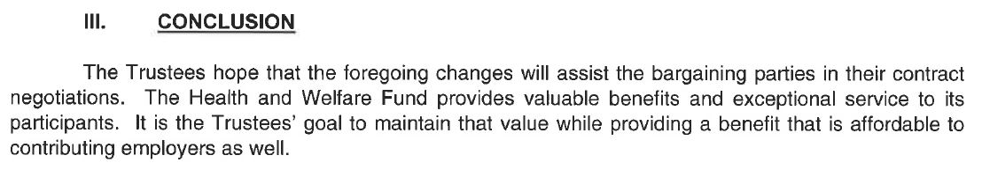
Health and Welfare
Model Contract Language for Tiered Rates

HEALTH AND WELFARE

Section 1.
Effective the Employer agrees to remit contributions to the Teamsters Health and Welfare Fund of Philadelphia and Vicinity in the manner described in the Sections below.

Section 2.
Effective the Employer shall contribute to the Teamsters Health and Welfare Fund of Philadelphia and Vicinity (hereinafter "Health and Welfare Fund") at the monthly amounts set forth immediately below on behalf of each employee (based upon the actual census of each respective employee) of the Employer covered by the terms of this Agreement:

Single $
Employee +1 $
Family $

Any change in the employee’s family status (marriage, divorce, birth or adoption of a child, etc.) shall be reflected in the Employer’s contribution rate as of the 1st of the month following the month in which the change occurs. It shall be the responsibility of the employee to report any change in family status both to the Employer and to the Health & Welfare Fund office. Once the change is reported, it shall be the responsibility of the Employer to remit the proper and appropriate contribution rate.

In the event adverse claims experience would otherwise require a reduction in any benefit program during the term of this Agreement, the Employer's contribution, as set forth in this Section, shall be increased in such amounts and at such times as the Trustees may determine to be necessary to maintain the benefit programs at the levels in effect as of the date of the contribution increase, but in any event, such increase may not exceed a maximum often percent (10%) per contract year as needed.

Section 3.
The Employer contributions referred to above shall cover medical, dental, vision, disability, prescription and death benefits. The nature and amount of such benefits shall be determined from time to time by the Trustees of the Health and Welfare Fund.

Section 4.
Contributions shall be made by the Employer as set forth in Section 2 above for each employee who performs work covered by this Agreement. Additionally, if an employee is absent because of illness or off-the­ job injury for two (2) consecutive weeks and notifies the Employer of such absence, the Employer shall make the required contributions from the first day for a maximum of one (1) additional month. If an employee is injured on-the-job, the Employer shall continue to pay the required contributions until such employee returns to work; however, during any period of such on-the­ job injury, such contributions shall not be paid for a period of more than six (6) months.

The amount of contribution payable under this Section shall be that set forth in Section 2 above and shall reflect the actual demographics of each respective employee. It is understood and agreed by and among the parties that no employee may opt-out of coverage or opt a dependent of that employee out of coverage under any circumstances.

Section 5.
The sums required by Section 2 above shall be remitted monthly to the Health and Welfare Fund. Such monthly payment shall be submitted to the Health and Welfare Fund on or before the fifth (5th) day of the month during which the employee is performing work covered by the terms of this Agreement.

Section 6.
The Union may suspend the operations of a delinquent Employer three (3) working days after receipt of a verification by telegram, registered or certified mail, that such Employer is delinquent in its contributory obligations to the Health and Welfare Fund. Copies of the verification shall be sent by the Administrator of the Health and Welfare Fund to the Employer and the Local Union.

Section 7.
Failure on the part of the Employer to contribute as specified herein above, shall make the Employer liable for all claims, damages, attorneys' fees, court costs, plus all arrears in payment, plus ten percent (10%) as liquidated damages.

Section 8.
The Employer shall complete and deliver to the Health and Welfare Fund, on forms supplied by the Health and Welfare Fund, an Employer's report stating the name and social security number for each regular, probationary, extra or casual employee employed by the Employer during the calendar month.

Section 9.
The Trustees of the Health and Welfare Fund shall have the right to require the Employer to make available to the Trustees or their duly accredited representatives, all time cards, payroll records, social security records, withholding tax records for the employees covered by this Agreement.

Section 10.
By execution of this Agreement, the Employer authorizes the Transport Employers' Association, or its successor, to enter into appropriate trust agreements necessary for the administration of the Health and Welfare Fund and agrees to be bound by the terms of said trust agreements, thereby waiving all notice thereof and ratifying all actions already taken or to be taken by such Trustees within the scope of their authority.

